CSA 283: Exam One

Name: ______________________________________ Section: _____ _____

Please write legibly. Ask questions if something is unclear. Be concise in written answers.

You may go to Benton 002 to complete the last two questions. There you may use the Java 2 Platform Std. Ed. 6.0 documentation at http://java.sun.com/javase/6/docs/api/. You may not use any other documentation or notes unless you want to get a zero for the exam.

Some useful formulas:
d_{trans} = L/R d_{prop} = d/s

L – packet length, R – link bandwidth, d – distance, s – propagation speed

Questions:

- List the five protocol layers of the Internet in order from highest to lowest. (5 points)

________________

________________

________________

________________

________________

- List the two major architectures or paradigms used to design the networked applications
(4 points)

______________________________

______________________________

- List the four sources of nodal delay. (4 points)

_________________

_________________

_________________

_________________
- Networks can be circuit switched or packet switched. Consider the characteristics below and identify which type of network the characteristic is associated with by writing either packet or circuit next to it as appropriate.
(7 points)

______________ Reserved bandwidth for each connection.

______________ Network bandwidth is shared using statistical multiplexing.

______________ Guaranteed time delay.

______________ Connection setup required by the network.

______________ Stores and forwards discrete “chunks” of data.

______________ Network bandwidth divided into pieces using techniques such as TDM and FDM.

______________ Aggregate resource demand can exceed available bandwidth.

- Give definitions for the following terms using one or two sentences. If the term is an acronym, also state what the letters in the acronym stand for and give a definition.
(10 points)

a. Out of Band:

b. Protocol:

c. Loss-tolerant application:

d. Traffic Intensity:

e. Bandwidth:

- An institutional web cache (proxy server) can not hold every web page on the Internet. Can a web cache speed up access for all pages? Explain. (Your explaination is very important.) (4 points)

- List three reasons DNS uses a distributed database instead a centralized database.
(6 points)

________________

________________

________________

- Consider the following scenario:

You are designing a networked application in which a server continuously supplies data to clients at a high rate. The most important consideration is for clients to have the newest possible data at any given moment. The clients do not save the data and are not interested in a complete history. Which transport layer protocol would you use to support this application? Why? (4 points)

- Use the constants below to answer the following questions. Show work for partial credit. Indicate the units for each answer. Show times to four decimal places. Assume processing and queuing delays are negligible.

File Size 30 Mb
Packet Size 1.5 Mb
Link Bandwidth 20 Mbs
Link Lengths 30 Kilometers
Propagation Speed 2.8 x 10⁵ Kms

- Calculate the propagation delay for a single link. (2 points)

b. Calculate the transmission delay for a single packet and a single router.
(2 points)

- Assuming there are six links connected by routers as depicted below. If processing and queuing delays are negligible, how much time will be required for a single packet to travel from A to B. (4 points)
A
B

d. Again assume and queuing delays are negligible. For pipelined transmission with a transmission window of infinite size (A continuously transmits packets as fast as possible one after the other), calculate the time needed for the entire file to travel from A to B.
(6 points)

- Consider the following scenario:

The host joe.uc.edu wants the IP address of jenny.npr.org in order to create a socket connection. In the following, assume that all nodes including joe.uc.edu cache DNS records. All DNS caches are initially empty. The first query sent by joe.uc.edu is handled recursively. Assume all other queries are handled recursively as well. DNS server names are as follows:

TLD DNS server, edu: dns.tld.edu
TLD DNS server, org: dns.tld.org
Local DNS server, uc: local.uc.edu
Local DNS server, npr: local.npr.org
Authoritative DNS, npr: dns.npr.org
Authoritative DNS, uc: dns.uc.edu
Root DNS server: dns.root

- 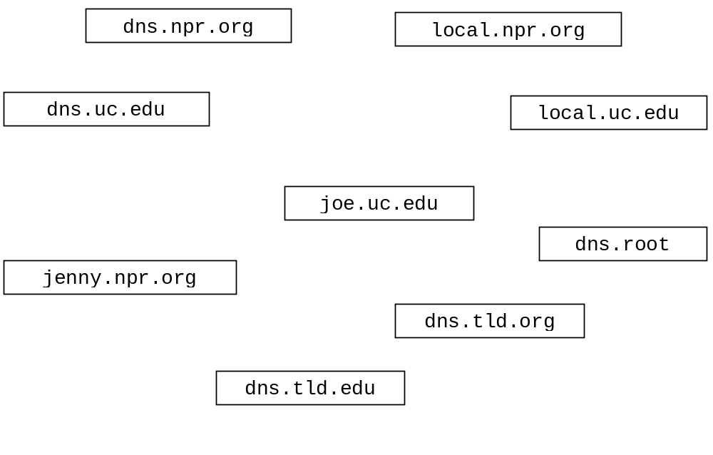Draw arrows labeled with numbers to indicate the order of queries and responses sent before joe.uc.edu receives the IP address of jenny.npr.org. (8 points)
- After the sequence in part a. has occurred, suppose mary.uc.edu wants the IP address for jenny.npr.org. How would the sequence of events be different?
(3 points)

- What type of resource record would actually contain the IP address of jenny.npr.org? (circle one) (2 points)

Type A Type NS Type CNAME Type MX

- Consider the following scenario:

An email message is sent from osama@alqaeda.com to omar@taliban.org. The following three transfers of the message are performed.

Transfer One: A firefox mail application running on 104.53.101.22 uploads the message to the mail server mail.foo.bar.com.

Transfer Two: mail.foo.bar.com contacts a mail server called po.taliban.org and uploads the message to po.taliban.org

Transfer Three: Eudora running on 123.99.200.14 is used to download the message from po.taliban.org.

For each of the transfers, name the application layer protocol that would normally be used. Specify which machine is the client and which is the server during the transfer (9 points)

Transfer One: Protocol: ______________

Client: ______________

Server: ______________

Transfer Two: Protocol: ______________

Client: ______________

Server: ______________

Transfer Three: Protocol: ______________

Client: ______________

Server: ______________

- In the previous question, the email message would undoubtedly contain some type of coding. If there is an attachment, what type of encoding would any email message be likely to contain? Why? (4 points)

- The TCPClient class below implements a simple client that sends two numbers to a server which sums them together and sends the sum back to the client. The server handles only one client and then exits. Write the server on the following page. USE TCP. Do not worry about handling exceptions. (24 points)

import java.io.*;
import java.net.*

public class TCPClient {

public static void main(String[] args) throws IOException
{
double numOne = 17.0;
double numTwo = 14.0;

Socket clientSocket = new Socket( "134.53.130.69", 6789);

DataOutputStream outToServer =
new DataOutputStream(clientSocket.getOutputStream());

DataInputStream inFromServer =
new DataInputStream( clientSocket.getInputStream());

outToServer.writeDouble( numOne );
outToServer.writeDouble( numTwo );

double sum = inFromServer.readDouble();

System.out.println("FROM SERVER: " + sum );

outToServer.close();
inFromServer.close();
clientSocket.close();

}
}
import java.io.*;
import java.net.*

public class TCPServer {

public static void main(String[] args) throws IOException
{

} // end main

} // end Server class
- Complete the server class below. Do not worry about handling exceptions. Allow the main method to throw all exceptions to the OS. (32 points)
- The server listens on port number 5544.
- Clients send the server two floats in a single packet using UDP. The first float is a base. The second number is an exponent.
- The Server raises the base to the exponent and sends this result back to the client as a double using UDP.
- When the client sends a negative base. The server closes down without sending a reply. Otherwise, it responds and continues running in order to handle other requests.

import java.io.*;
import java.net.*;

public class UDPPowerServer {

public static void main(String[] args) throws Exception
{

